|  |
| --- |
| EPAM Systems, RD Dep. |
| MTN.BI.08 Materialized Views |

|  |  |  |  |  |  |
| --- | --- | --- | --- | --- | --- |
| REVISION HISTORY | | | | | |
| Ver. | Description of Change | Author | Date | Approved | |
| Name | Effective Date |
| 1.0 | Initial status | [Hanna_Hul](mailto:Kiryl_Bucha@epam.com) | 12-JAN-2012 |  |  |

Contents

1. Materialized Views- Basic 3

1.1. Create Materialized Views - ON DEMAND 3

1.2. Create Materialized Views - ON COMMIT 3

2. Fact Table Loading 3

3. Task Results 3

# Materialized Views- Basic

## Create Materialized Views - ON DEMAND

Take any "report" SQL from Lab Work 02 and create Materialized View based on it. Refresh type is ON DEMAND.

* Use Standard CREATE MATERIALIZED VIEW CLAUSE.
* Use DBMS_MVIEW package to refresh Mat View.

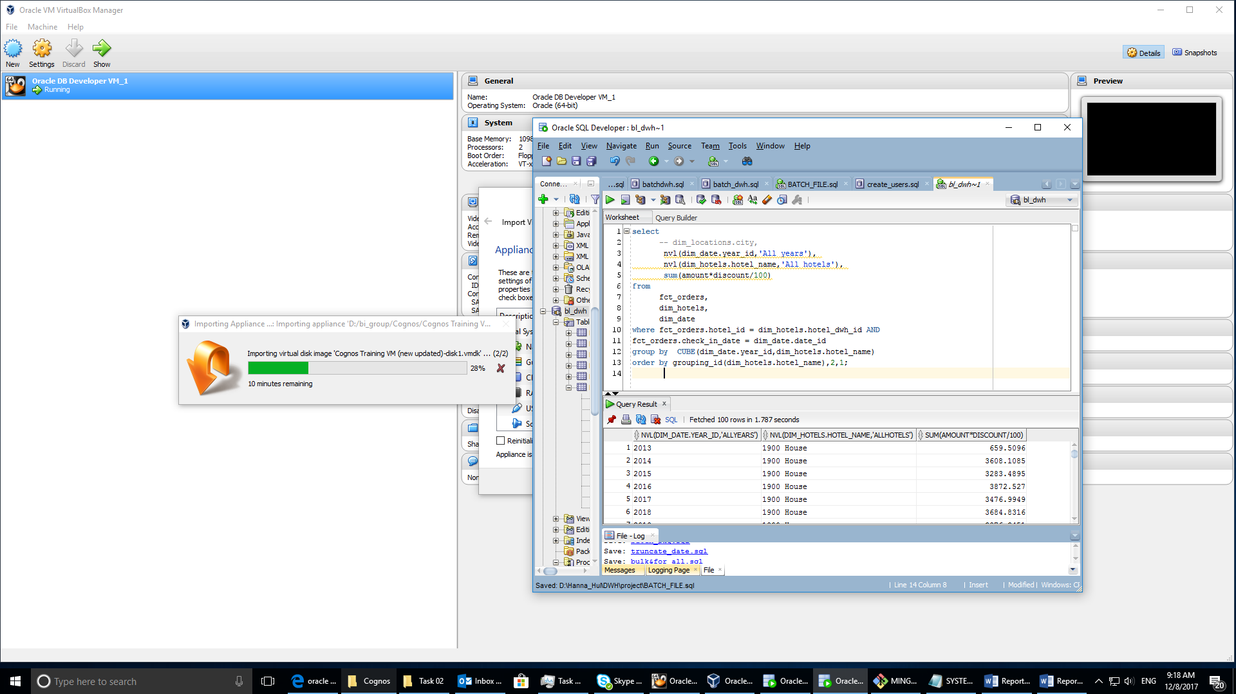

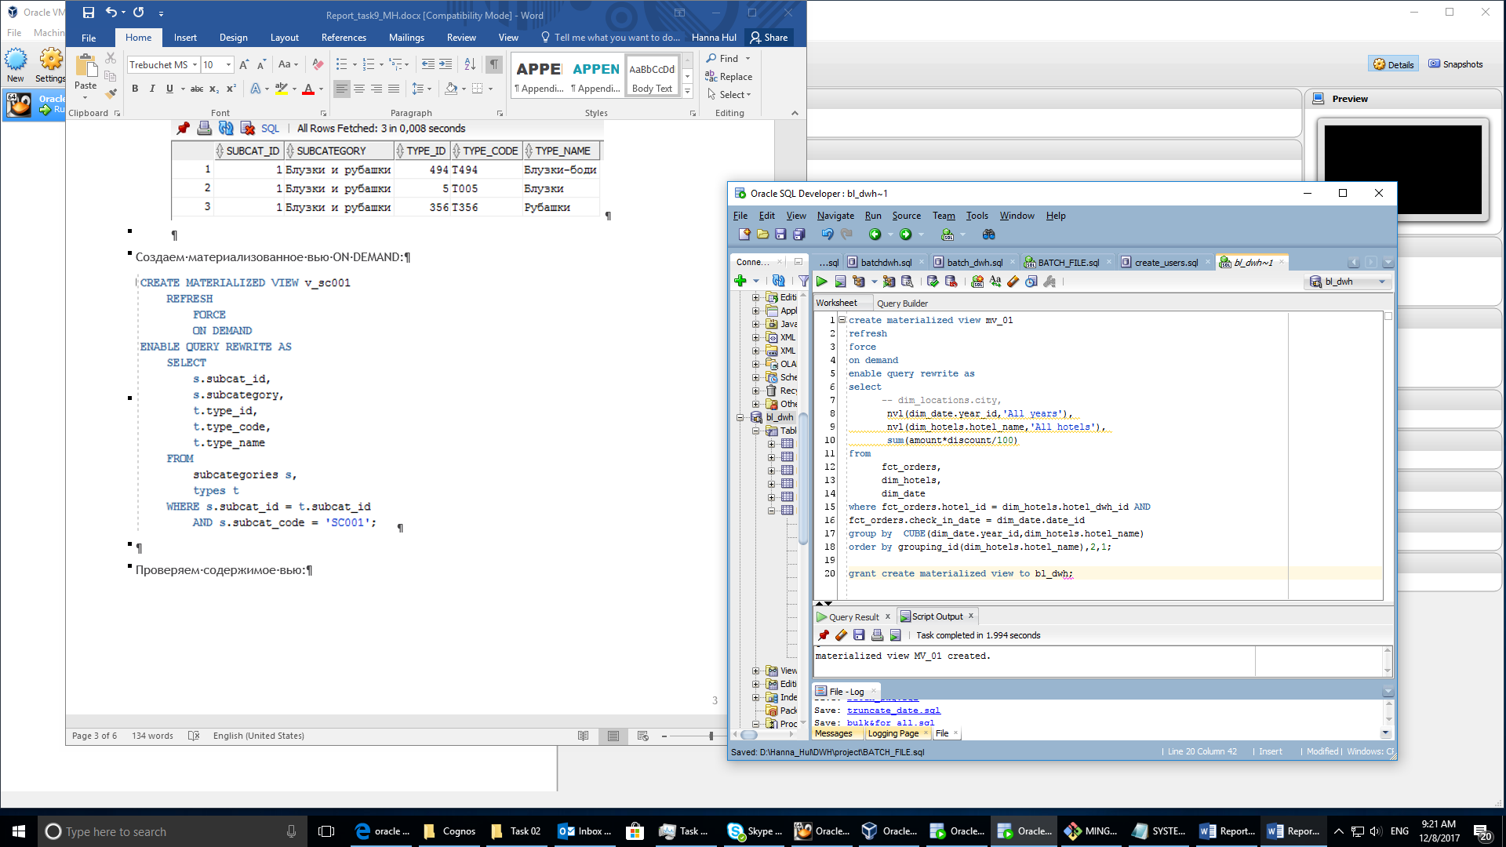

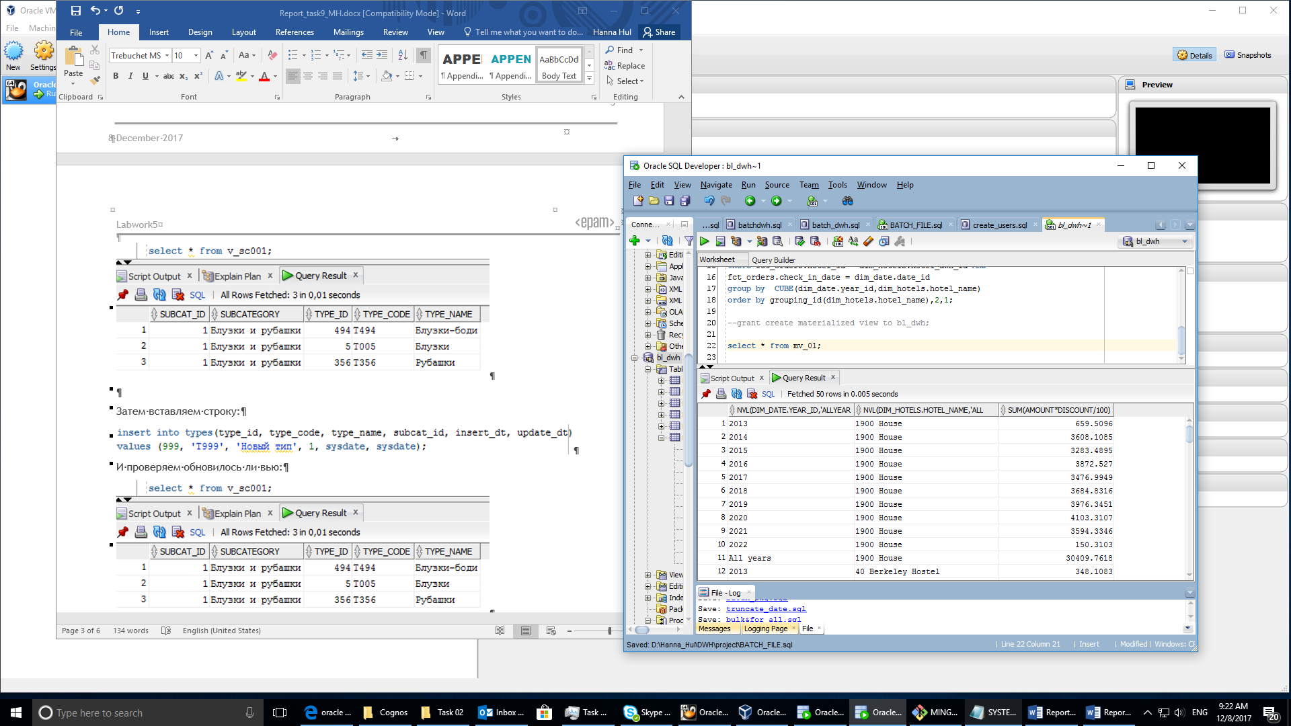

After deleting data from table nothing changed.

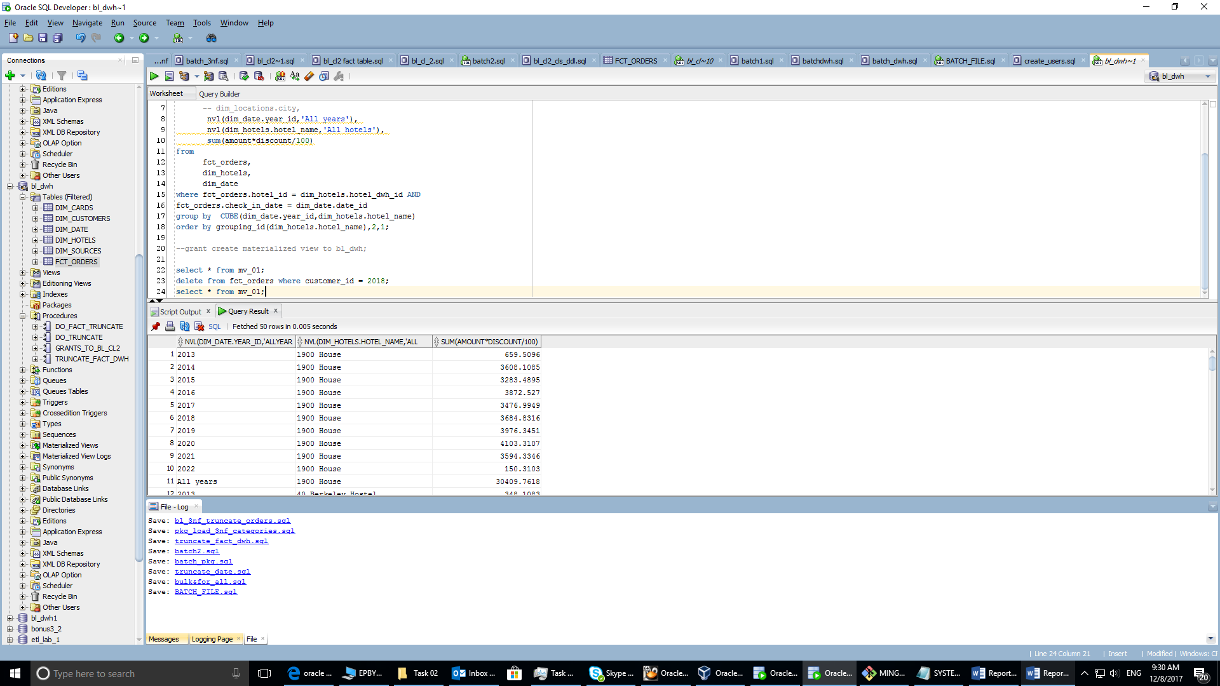

After

* execute dbms_mview.refresh('mv_01');

select * from mv_01 order by 2,1;

you could see changes.

## Create Materialized Views - ON COMMIT

Take any "report" SQL from Lab Work 02 and create Materialized View based on it. Refresh type is ON COMMIT.

* Use Standard CREATE MATERIALIZED VIEW CLAUSE.
* Tests ON COMMIT REFRESH.

